Kartik Panwar

UPES – Dehradun

HR Resume & LinkedIn Shortlisting Agent

Abstract
The HR Resume & LinkedIn Shortlisting Agent is an AI-powered recruitment assistance system developed to automate the candidate shortlisting process. The system analyzes resumes and LinkedIn profile information against a provided job description using Natural Language Processing (NLP) and semantic similarity techniques. It calculates a match score based on semantic similarity and skill matching to help recruiters identify suitable candidates quickly and efficiently.
The project uses spaCy for text preprocessing, Sentence Transformers for semantic embeddings, and cosine similarity for candidate-job matching. A modern web-based interface allows recruiters to upload resumes, paste job descriptions, and receive detailed AI-generated evaluation reports.

1. Introduction
Recruitment is one of the most important and time-consuming tasks in organizations. Human Resource departments often receive hundreds of resumes for a single job role. Manually analyzing resumes is inefficient and prone to errors.
The HR Resume & LinkedIn Shortlisting Agent solves this problem by using Artificial Intelligence and NLP techniques to automate candidate evaluation. The system compares candidate profiles with job requirements and generates accurate matching scores along with technical skill analysis.
The project helps:
- Reduce recruitment time
- Improve candidate screening accuracy
- Automate resume analysis
- Provide AI-based candidate summaries

2. Objectives
The main objectives of this project are:
- To automate resume shortlisting
- To analyze resumes using NLP techniques
- To calculate semantic similarity between resumes and job descriptions
- To identify matched and missing skills
- To generate AI-based candidate summaries
- To provide a user-friendly recruitment interface

3. Technologies Used
Technology | Purpose
Python | Backend development
FastAPI | REST API framework
spaCy | NLP preprocessing
Sentence Transformers | Semantic embeddings
Scikit-learn | Cosine similarity
PyMuPDF | PDF text extraction
HTML | Frontend structure
CSS | Frontend styling
JavaScript | Frontend functionality

4. System Architecture
The system architecture consists of three main layers:

4.1 Frontend Layer
The frontend provides a user-friendly interface where recruiters can:
- Upload resumes
- Enter job descriptions
- Add LinkedIn profile text
- View candidate evaluation results

4.2 Backend Layer
The backend is developed using FastAPI and handles:
- API requests
- Resume processing
- Skill extraction
- Similarity calculations
- Score generation

4.3 AI Processing Layer
This layer performs:
- Text preprocessing
- Embedding generation
- Semantic similarity calculation
- Skill matching
- Summary generation

5. Methodology

5.1 Resume Parsing
The uploaded resume PDF is processed using PyMuPDF to extract textual content.

5.2 NLP Preprocessing
spaCy is used for:
- Tokenization
- Lemmatization
- Stopword removal
- Text normalization

5.3 Skill Extraction
The system compares extracted text with a predefined skills database stored in skills.json.

5.4 Embedding Generation
Sentence Transformer model:
all-MiniLM-L6-v2
is used to convert text into semantic vector embeddings.

5.5 Semantic Similarity
Cosine similarity is calculated between:
- Resume embeddings
- Job description embeddings

5.6 Match Score Calculation
The final score is calculated using:
$$score=0.6×semantic_similarity+0.4×skill_match$$
Where:
- 60% weight is given to semantic similarity
- 40% weight is given to skill matching

6. Features of the System

Core Features
- Resume PDF Upload
- Job Description Input
- LinkedIn Profile Support
- Semantic Similarity Analysis
- Skill Matching
- Match Score Generation
- AI Candidate Summary
- Dynamic Frontend Dashboard

Additional Features
- Error handling
- Modern UI design
- Real-time API communication
- Loading animation
7. API Design

Endpoint

POST /analyze

Inputs
- Resume PDF
- Job Description
- LinkedIn Profile Text (Optional)

Output
- Match Score
- Semantic Similarity
- Skill Match Score
- Extracted Skills
- Matched Skills
- Missing Skills
- AI-generated Summary

8. Frontend Design
The frontend interface is built using:
- HTML
- CSS
- JavaScript

UI Components
- Resume Upload Section
- Job Description Text Area
- LinkedIn Input Section
- Analyze Button
- Result Dashboard
The interface uses:
- Card-based layout
- Responsive design
- Skill badges
- Loading animation

9. Advantages of the System
- Saves recruitment time
- Reduces manual effort
- Improves hiring efficiency
- Provides intelligent candidate analysis
- Helps HR teams make faster decisions
- Accurate semantic matching

10. Limitations
- Depends on predefined skills database
- Limited understanding of complex resume formats
- Requires good quality PDF resumes
- No database storage in current version

11. Future Enhancements
Future improvements may include:
- Multi-resume ranking system
- Recruiter dashboard
- Authentication system
- Database integration
- Cloud deployment
- AI recommendation engine
- Advanced LinkedIn scraping
- Real-time hiring analytics

12. Sample Output
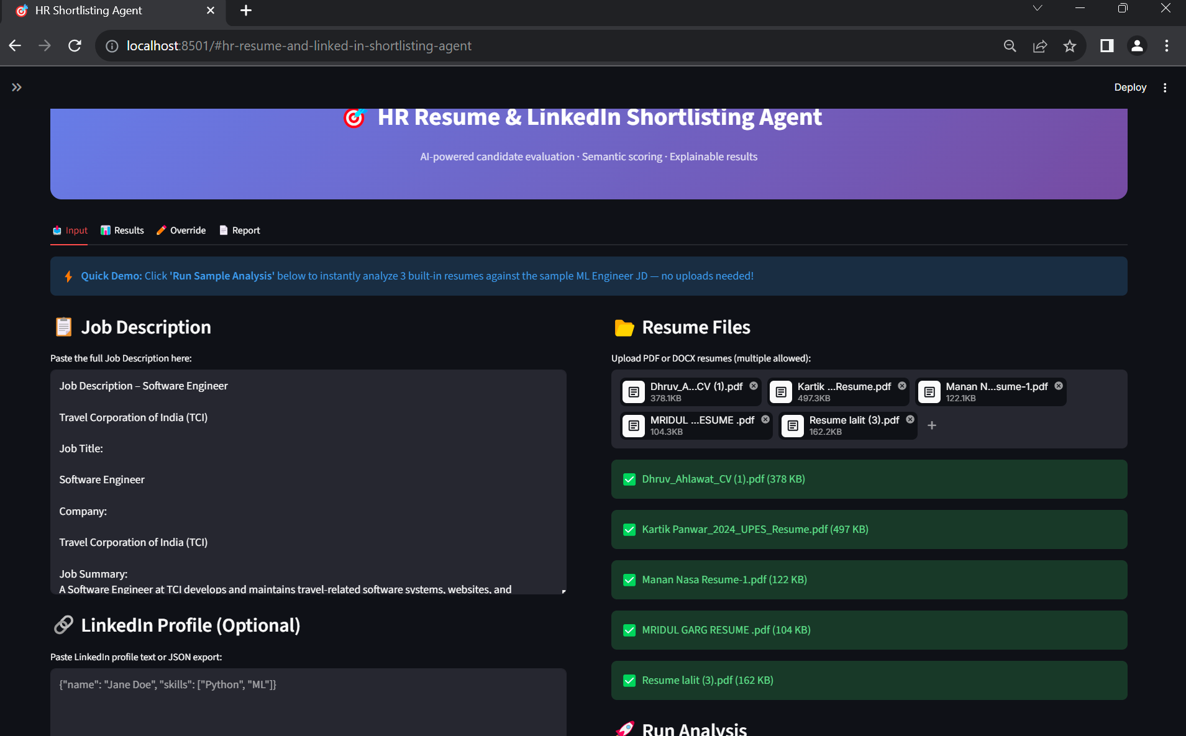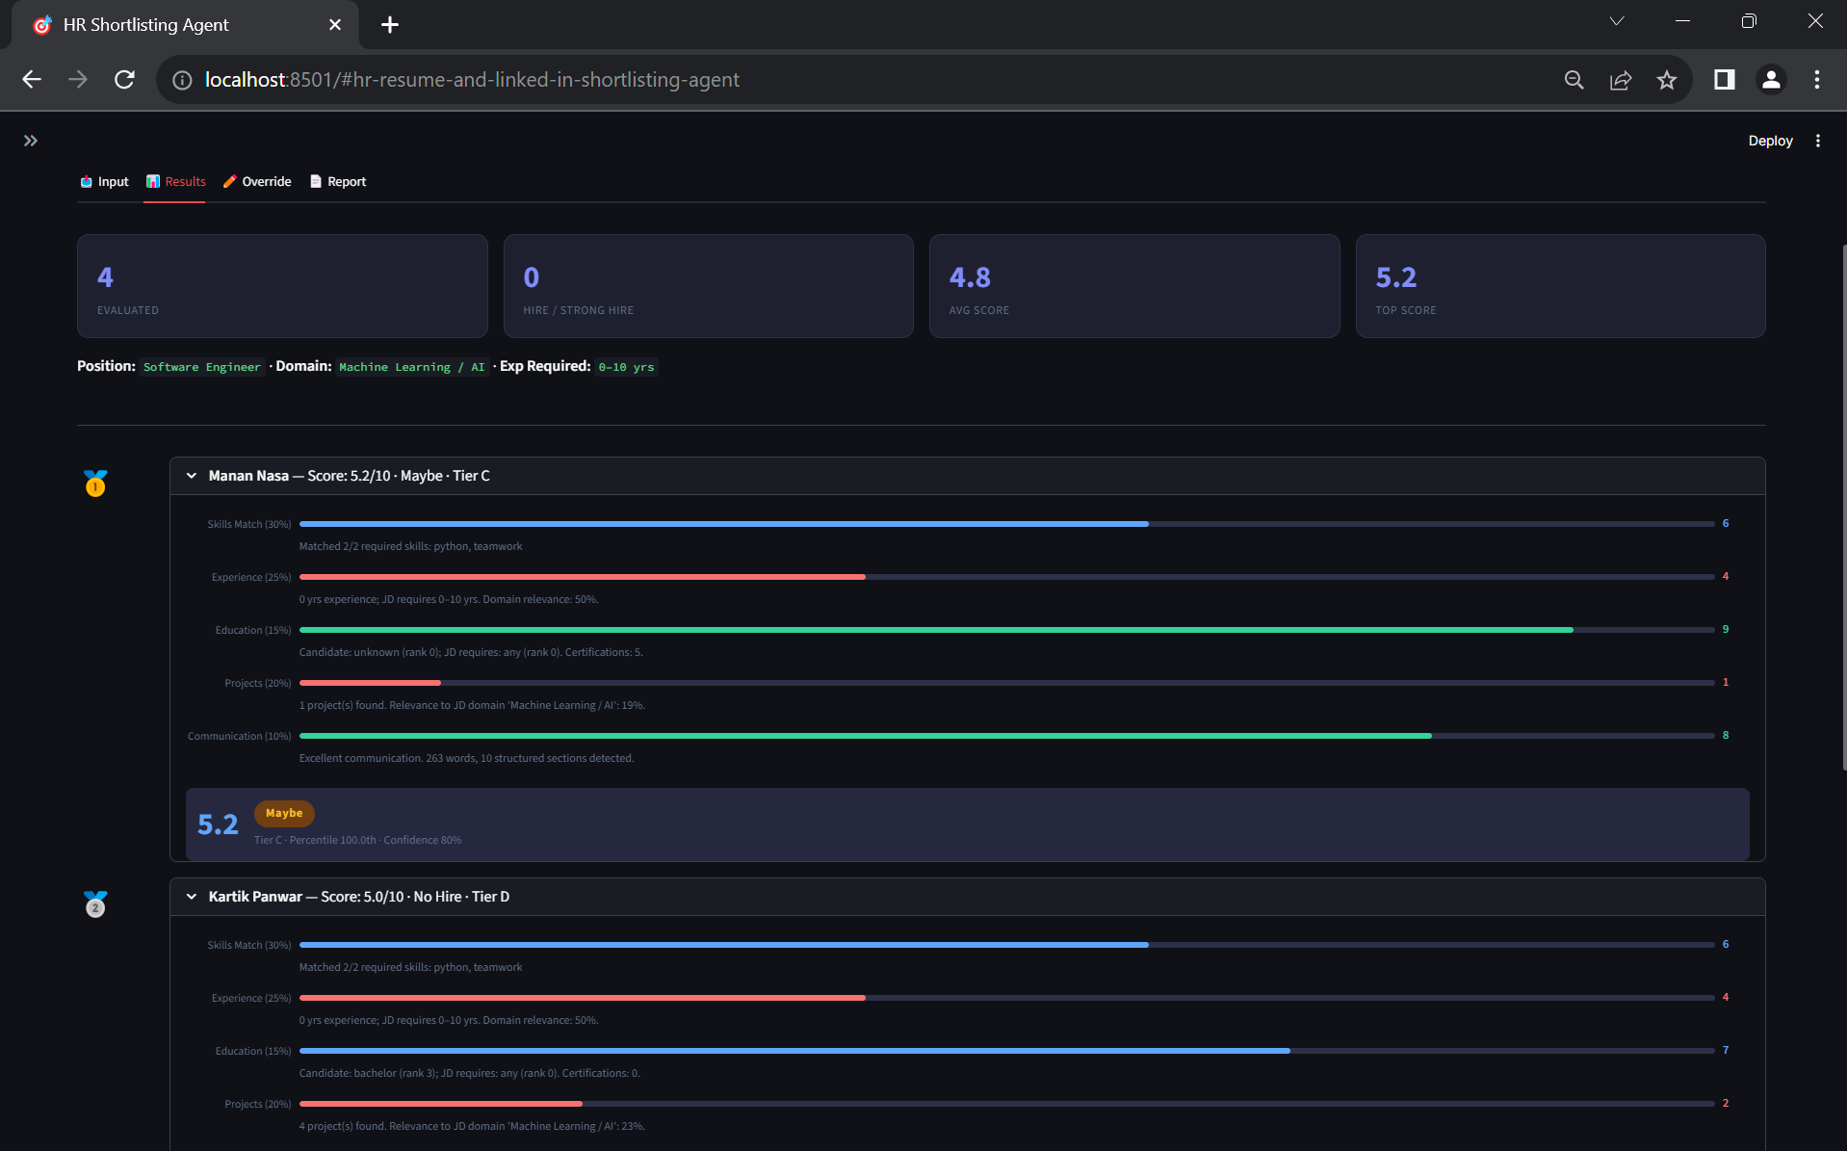
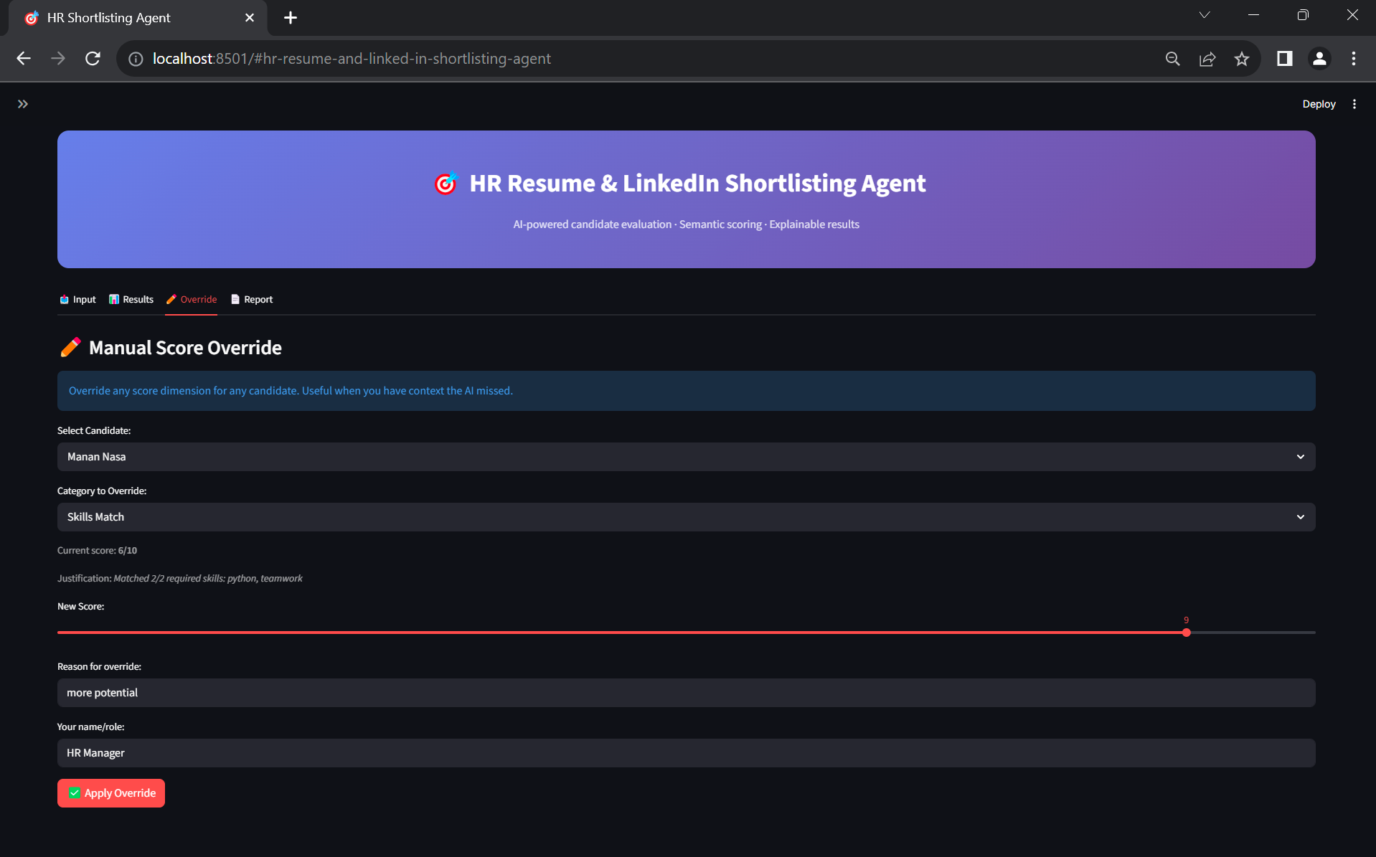
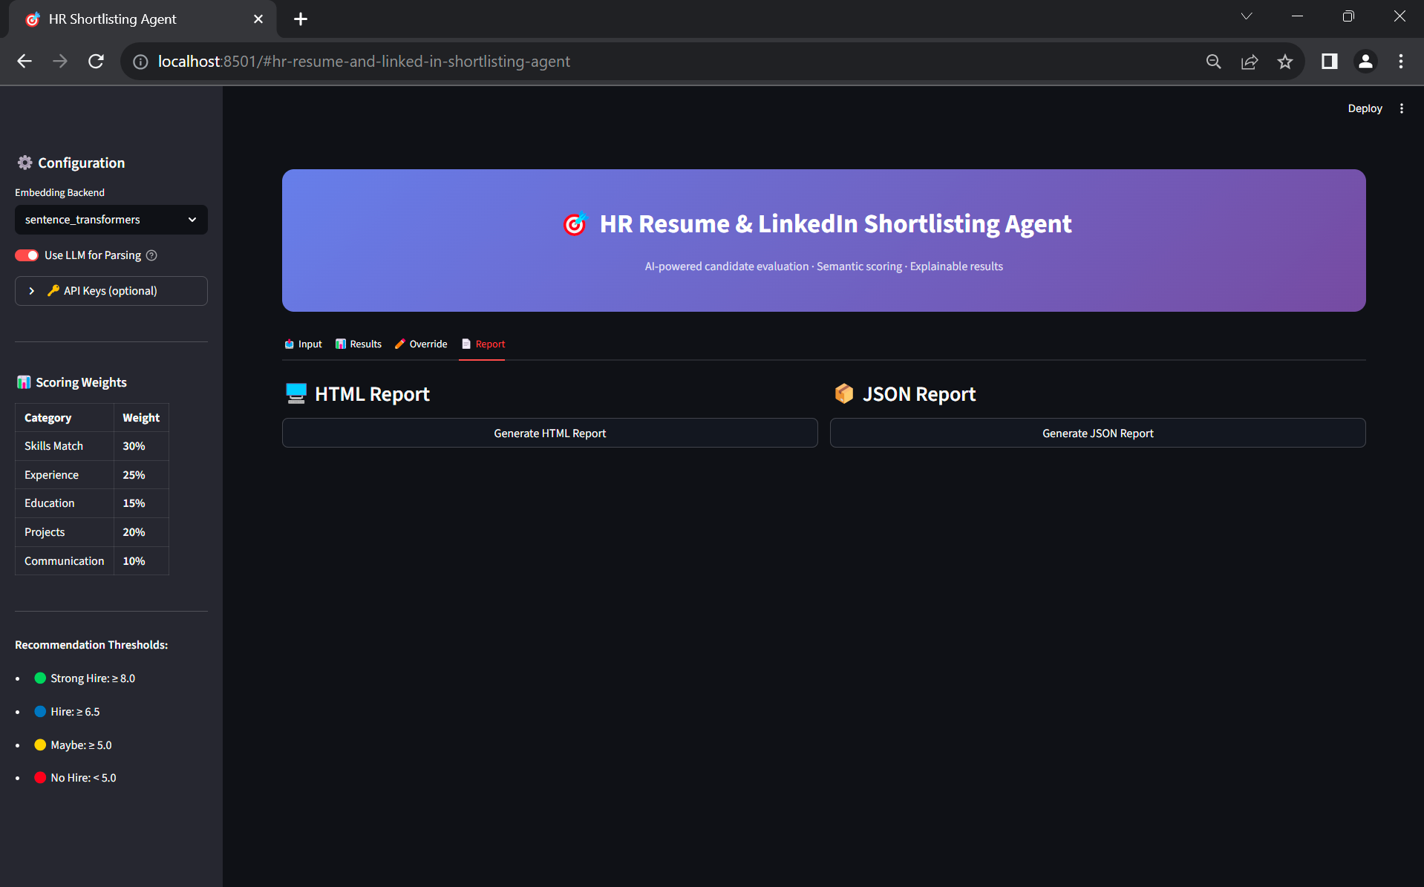
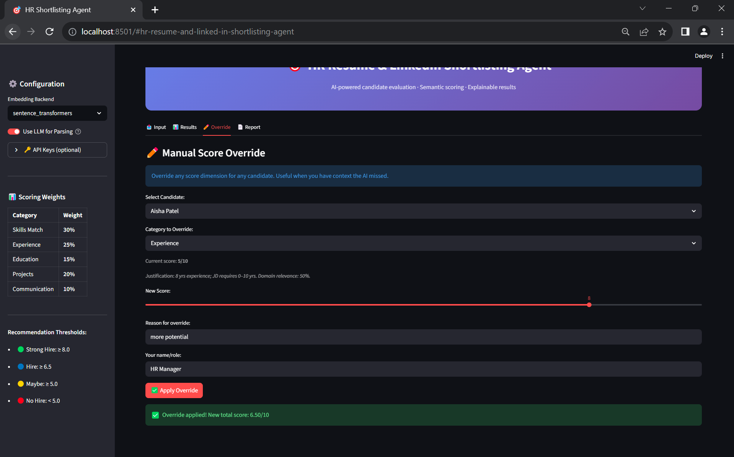

AI Candidate Summary
The candidate demonstrates strong technical expertise in machine learning and backend API development. The profile shows high semantic alignment with the job description and strong suitability for the role.

13. Conclusion
The HR Resume & LinkedIn Shortlisting Agent successfully automates the recruitment screening process using AI and NLP technologies. The system provides accurate candidate-job matching through semantic analysis and skill extraction. By reducing manual workload and improving screening efficiency, the project demonstrates the practical application of AI in Human Resource Management.
The project can be further enhanced with advanced machine learning models, recruiter dashboards, and cloud deployment to create a scalable enterprise-level recruitment solution.

14. Reference

1. Core Software & Documentation
These follow the standard format for citing software and technical manuals.
- spaCy Documentation
Honnibal, M., Montani, I., Van Landeghem, S., & Boyd, A. (2020). spaCy: Industrial-strength Natural Language Processing in Python. https://spacy.io/
- Sentence Transformers
Reimers, N., & Gurevych, I. (2019). Sentence-BERT: Sentence Embeddings using Siamese BERT-Networks. In Proceedings of the 2019 Conference on Empirical Methods in Natural Language Processing. https://www.sbert.net/
- FastAPI
Ramírez, T. (2018). FastAPI framework, high performance, easy to learn, fast to code, ready for production. https://fastapi.tiangolo.com/
- Scikit-learn
Pedregosa, F., Varoquaux, G., Gramfort, A., Michel, V., et al. (2011). Scikit-learn: Machine Learning in Python. Journal of Machine Learning Research, 12, 2825–2830.
- PyMuPDF (fitz)
McKie, R., & Liu, Z. (2024). PyMuPDF: High performance rendering and analysis of PDF and other document formats. https://pymupdf.readthedocs.io/

2. Natural Language Processing (NLP) Research
These papers focus on modern NLP techniques for document parsing and interpretation, relevant to your work on the National Education Policy (NEP) 2020.
- AI-Driven Policy Interpretation
Kumar, R., et al. (2026). An AI-Driven Resume Parsing and Automated Interview Question Generation System using Natural Language Processing. International Journal of Innovative Research in Computer and Communication Engineering.

- Information Extraction & Parsing
Sharma, A., & Gupta, P. (2025). An AI-Driven Resume Parsing and Ranking System Using Natural Language Processing. International Journal of Creative Research Thoughts.

3. Machine Learning in Recruitment Systems
These sources provide the context for "intelligent" recruitment and screening systems, addressing both efficiency and the ethical implications of AI in hiring.
- Strategic Frameworks in Recruitment
(2026). A Study on the Role of Artificial Intelligence in Recruitment and Selection. International Journal of Creative and Open Research in Engineering and Management, 2(4), 1–9.
- Algorithmic Efficiency & Bias
Raghavan, M., et al. (2020). Mitigating bias in algorithmic hiring: Evaluating claims and practices. Proceedings of the 2020 Conference on Fairness, Accountability, and Transparency.
- Global Industry Reports (Report File Reference)
World Economic Forum. (2025). The Future of Jobs Report 2025. WEF Publications. https://reports.weforum.org/

